**Pachakala Kiran Kumar (19001200)**

**OUTPUT:**

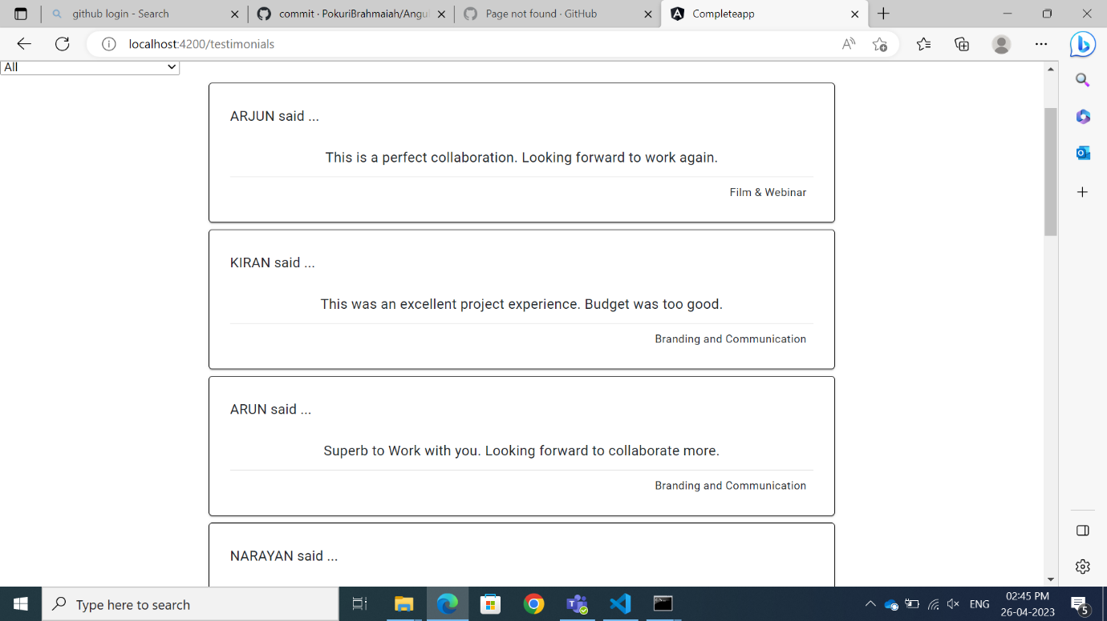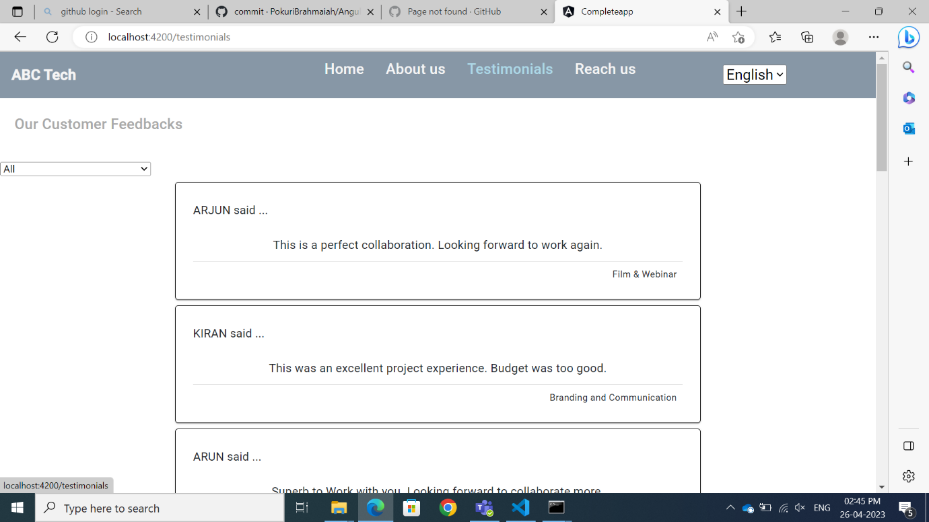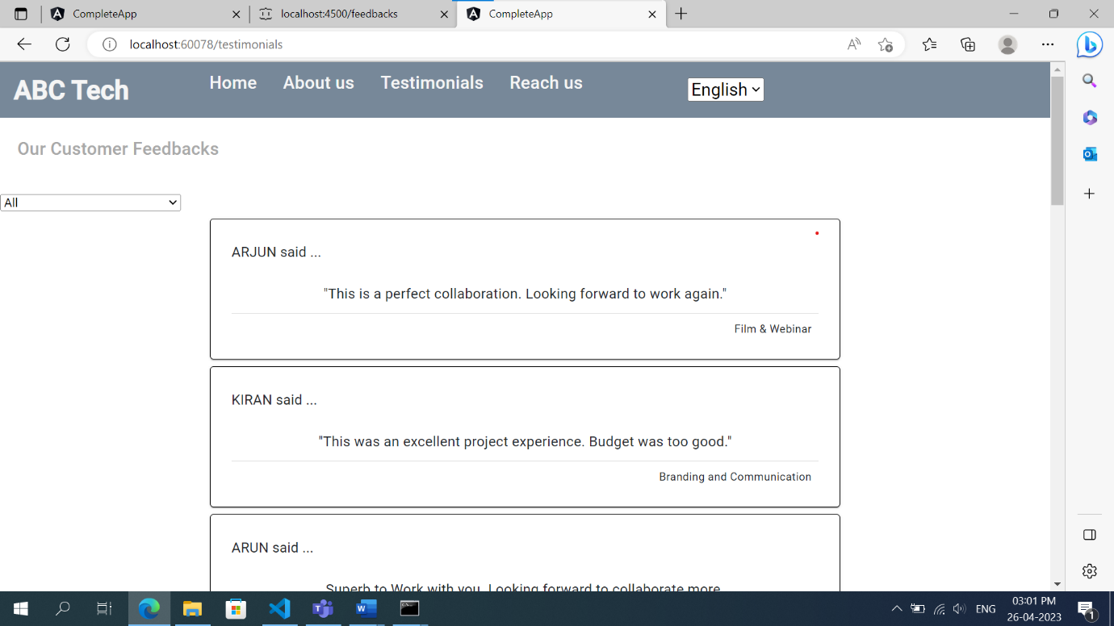

**Workflow:** @Input

Data

Child

Component

Parent

Component

Services

Server

APIcall

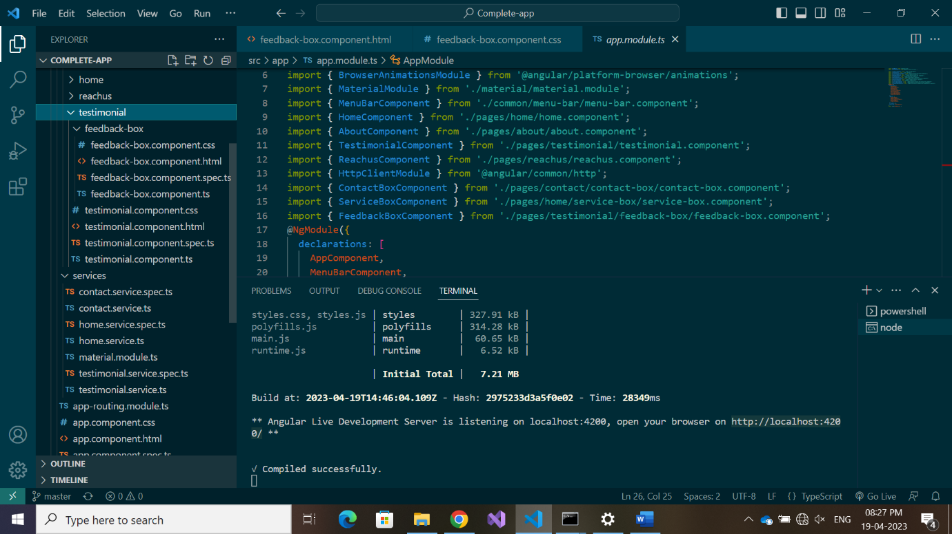

Service – testimonial.service.ts

Parent Component – testimonial

Child Component – feedback-box